Assessment Schedule – 2014
Chemistry: Demonstrate understanding of the properties of organic compounds (91391)

Evidence Statement
Q | Evidence | Achievement | Achievement with Merit | Achievement with Excellence
ONE  (a) | 3-chlorobutanone  CH₃ – CH₂ – CO – NH₂  methylbutanoate | - TWO correct.
(b)(i)  (ii) | 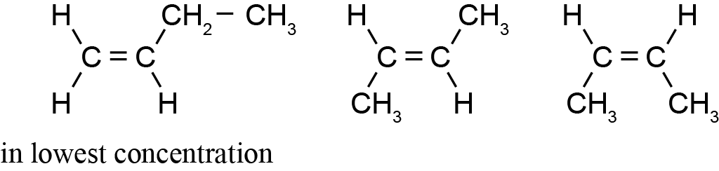  The minor product is but-1-ene.  Saytzeff’s rule: the minor product will have the least substituted double bond OR  Saytzeff’s rule is explained.  Eg: the minor product is formed by the removal of the OH group and a hydrogen atom is removed from the carbon adjacent to the C-OH that has the most hydrogens. | - Two isomers. | - All three isomers.  OR  Two isomers and correct choice with partial explanation. | - All three isomers.  AND  Correct choice with explanation.
(c)(i)  (ii) | Ester group:  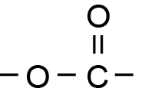  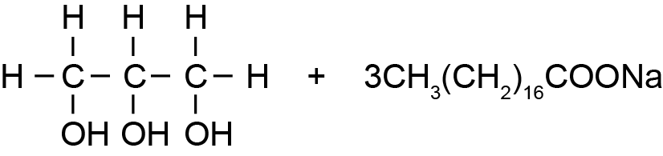  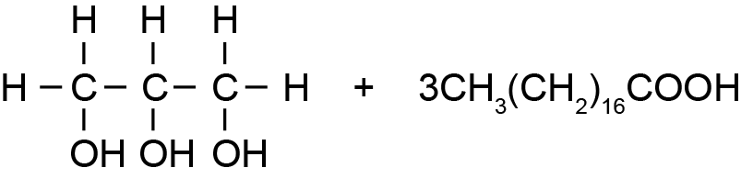  Both acidic and basic hydrolysis produce the same alcohol  propan-1,2,3-triol.  In addition, they both require heat / reflux  In contrast, acidic hydrolysis requires H₂O / H⁺ or HCl(aq) and produces the carboxylic acid, whereas basic hydrolysis requires H₂O / OH– or NaOH(aq) and produces the carboxylate ion/salt. | - Correct functional group circled AND named.  - One correct structure.  OR  Partial discussion. | - Two unique products linked to the type of hydrolysis.  OR  Products of one reaction correctly linked to the type of hydrolysis and reagent or conditions. | - Comparison and contrast of hydrolysis to give salt / acid and alcohol.  Reagents with conditions and structures correct.

NØ | N1 | N2 | A3 | A4 | M5 | M6 | E7 | E8
No response or no relevant evidence. | 1a | 2a | 3a | 4a | 1m & 3a | 2m | 2e with minor error or omission, or have not compared and contrasted. | 2e

Q | Evidence | Achievement | Achievement with Merit | Achievement with Excellence
TWO  (a)(i)  (ii)  (iii) | Damp red litmus.  Propanamine will change the colour of red litmus blue.  Propanamide will not change the colour of red litmus.  Tollens’ reagent (Fehling’s or Benedict’s or Cr₂O₇^{2–} / H⁺ or MnO₄– / H⁺).  Propanal will form a silver mirror when warmed with Tollens’ reagent.  Propanone will not react with Tollens’ reagent.  Water.  Propanoyl chloride will react violently with water.  Propyl propanoate with not react with water / it will form layers. | - Two correct reagents.  - Correct observation for ONE compound. | - TWO pairs of compounds distinguished with reagents and observations linked to the relevant species. | - ALL pairs of compounds distinguished with reagents, conditions and observations linked to species.
(b)(i)  (ii)  (iii)  (iv) | Gas = Carbon dioxide / CO₂  NaHCO₃ is used to remove any remaining acid mixed with the liquid product.  Na₂SO₄ is added to remove any remaining water mixed with the liquid product.  Fractional Distillation.  Equipment 1.  The purpose of the process is to purify the chemical / remove impurities / separate product  - This is achieved by separating liquids according to their boiling points.  - Chemicals are boiled then condensed / liquid-gas then gas-liquid.  - The fraction at the desired boiling point is kept / other fractions are discarded. | - (i) OR (ii) correct.  - (iii) is correct.  - Correct purpose.  OR  Partial explanation. | - All correct from (i) – (iii).  - Correct purpose.  AND  Partially explained. | - Comprehensive discussion.

NØ | N1 | N2 | A3 | A4 | M5 | M6 | E7 | E8
No response or no relevant evidence. | 1a | 2a | 3a | 4a | 2m | 3m | 2e with minor error or omission, such as a missing condition. | 2e

Q | Evidence | Achievement | Achievement with Merit | Achievement with Excellence
THREE  (a) | A = Propan-2-ol  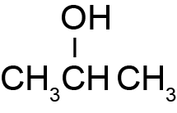  B = Propan-1-ol  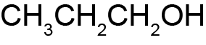  C = Propanone  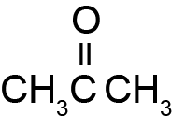  D = Propanoic acid  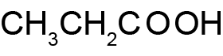  E = Propanoyl chloride  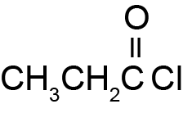  F = Propanamide  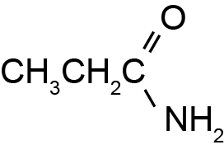  G = Propyl propanoate  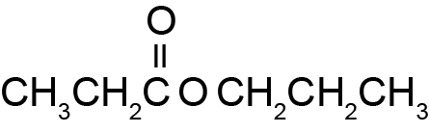  H = Methyl ethyl propanoate (not required)  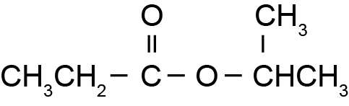 | - FIVE correct structures.  - FIVE correct names. | - ELEVEN structures or names correct. | - FOURTEEN structures or names correct.  (Penalise once for –HO / –H₂N.)

(b) | 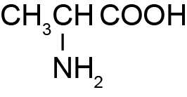  Acid hydrolysis conditions:  H₂O/H⁺ or HCl(aq)  and  heat or reflux  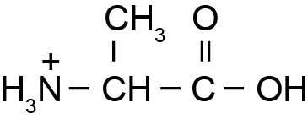  Basic hydrolysis conditions:  H₂O/OH¯ or NaOH(aq)  and  heat or reflux  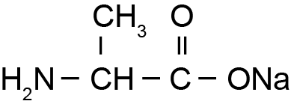 | - Monomer structure contains amine or carboxylic acid or acyl chloride.  - Acidic hydrolysis conditions.  OR  Basic hydrolysis conditions.  OR  ONE Structure correct. | - Correct monomer structure.  - One product of hydrolysis linked to type of hydrolysis and condition.  OR  Two structures. | - Both hydrolysis products and conditions.

NØ | N1 | N2 | A3 | A4 | M5 | M6 | E7 | E8
No response or no relevant evidence. | Part statement for Achievement  (three boxes from (a)) | 1a | 2a | 3a | 2m | 3m | 2e with minor error or omission.  Eg: omitting H₂O and heat | 2e

Cut Scores
 | Not Achieved | Achievement | Achievement with Merit | Achievement with Excellence
Score range | 0 – 7 | 8 – 13 | 14 – 18 | 19 – 24

